**LAB TASKS**

**Q1:**

**CODE  
RESULTS**

void setup() {  
 Serial.begin(9600); // Setting up serial communication at 9600 bps  
}  
// Repeatedly reading and printing analog sensor values from pin A2 to Serial Monitor  
void loop() {  
 Serial.println(analogRead(A2)); // Print the analog sensor value  
delay(100); // Delay for 100 microseconds  
}

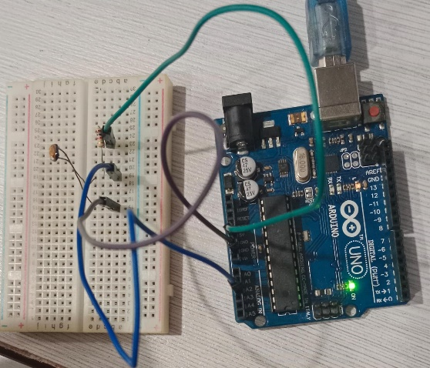**Working during lab session on Question 1**



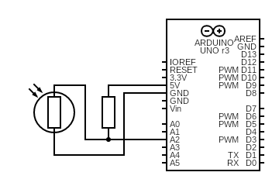

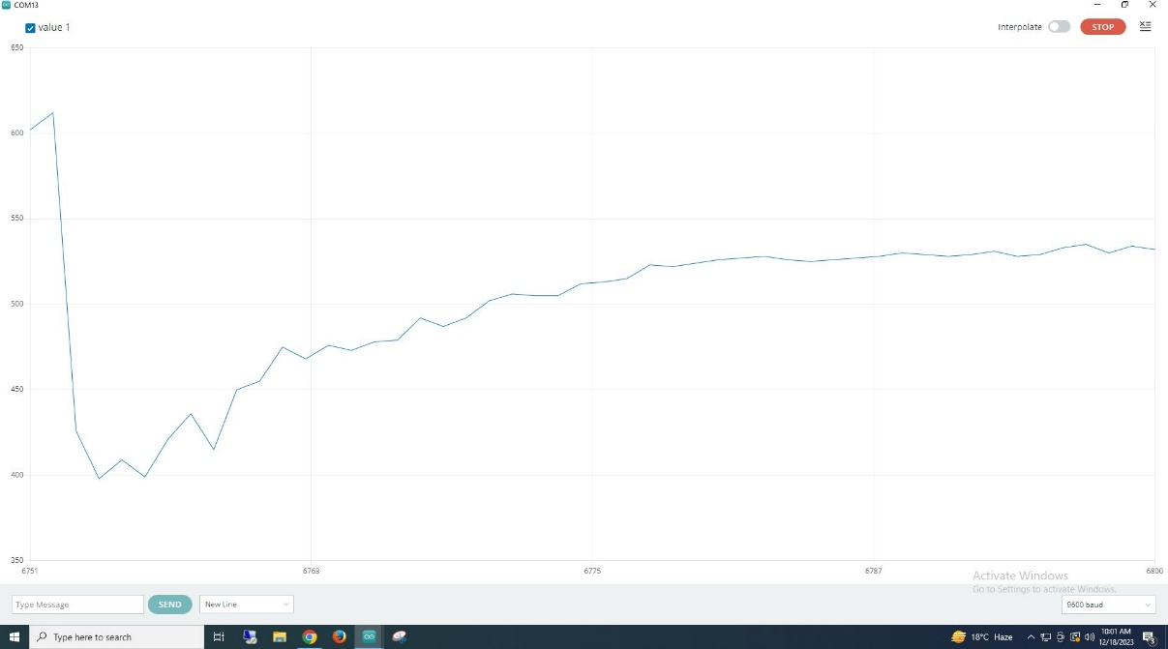

**Q2:**

**CODE**

int mp; //variable to store analog sensor readings  
int cake; //variable to store raw sensor value   
void setup() // put your setup code here, to run once:  
{  
pinMode(6,OUTPUT); //set pin 6 as an output  
Serial.begin(9600); //begin a baud rate at 9600 bps  
}  
void loop() // put your main code here, to run repeatedly:  
{  
cake = analogRead(A2); //read the analog input from pin A2  
Serial.print("LDR i/p value is: "); //print the sensor value to the serial monitor  
Serial.println(cake); //print value that is stored in variable “cake”  
mp = map (cake , 0, 1023, 0 ,255); // Map the sensor value from the range 0-1023 to 0-255  
analogWrite(6, mp); // Set the brightness of the LED connected to pin 6 based on the mapped value  
Serial.print("LED value is: "); //print the LED brightness value to the serial monitor   
Serial.println (mp); //print the value that is stored in variable  
Serial.println(""); // Print an empty line for better readability in the Serial Monitor  
delay (1000); //delay for 1microseconds  
}

**RESULTS**

**Working during lab session on Question 2 Used different software for circuit**

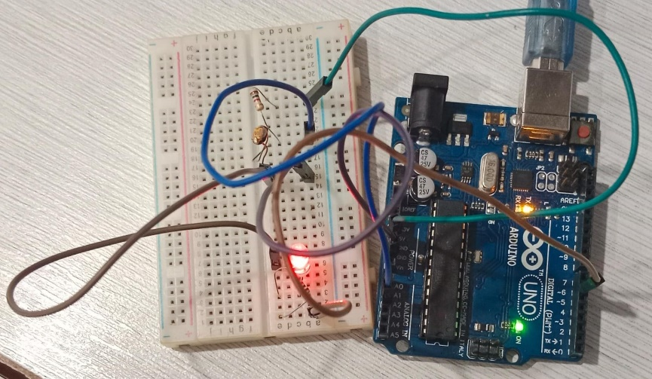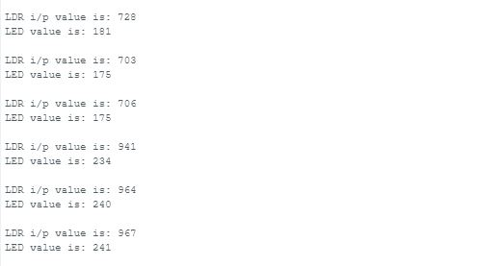

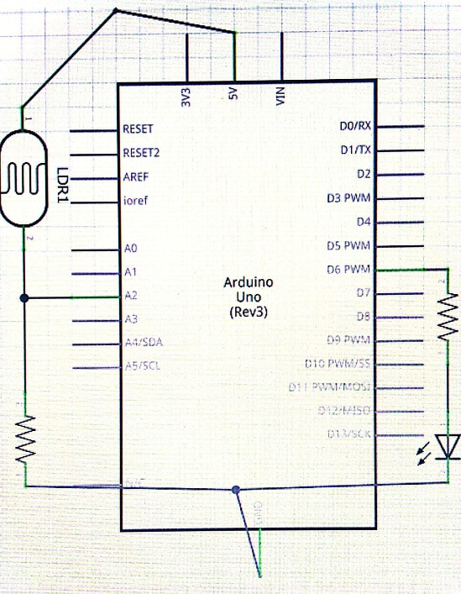

**Q3:**

**CODE**

int mp; //variable to store analog sensor readings  
int cake; //variable to store raw sensor value   
void setup() // put your setup code here, to run once:  
{  
pinMode(6,OUTPUT); //set pin 6 as an output  
Serial.begin(9600); //begin a baud rate at 9600 bps  
}  
void loop() // put your main code here, to run repeatedly:  
{  
cake = analogRead(A2); //read the analog input from pin A2  
Serial.print("LDR i/p value is: "); //print the sensor value to the serial monitor  
Serial.println(cake); //print value that is stored in variable “cake”  
mp = map (cake , 0, 1023, 0 ,255); // Map the sensor value from the range 0-1023 to 0-255  
analogWrite(6, mp); // Set the brightness of the LED connected to pin 6 based on the mapped value  
Serial.print("LED value is: "); //print the LED brightness value to the serial monitor   
Serial.println (mp); //print the value that is stored in variable  
Serial.println(""); // Print an empty line for better readability in the Serial Monitor  
delay (1000); //delay for 1microseconds  
}

**RESULTS**

**Working during lab session on Question 3**

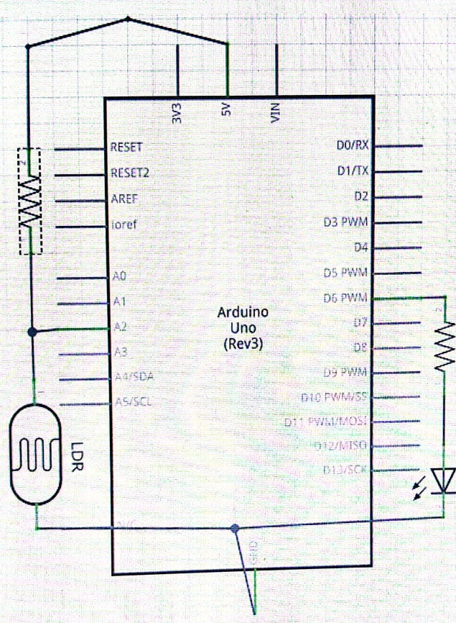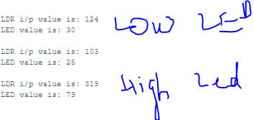

LOW LED

HIGH LED

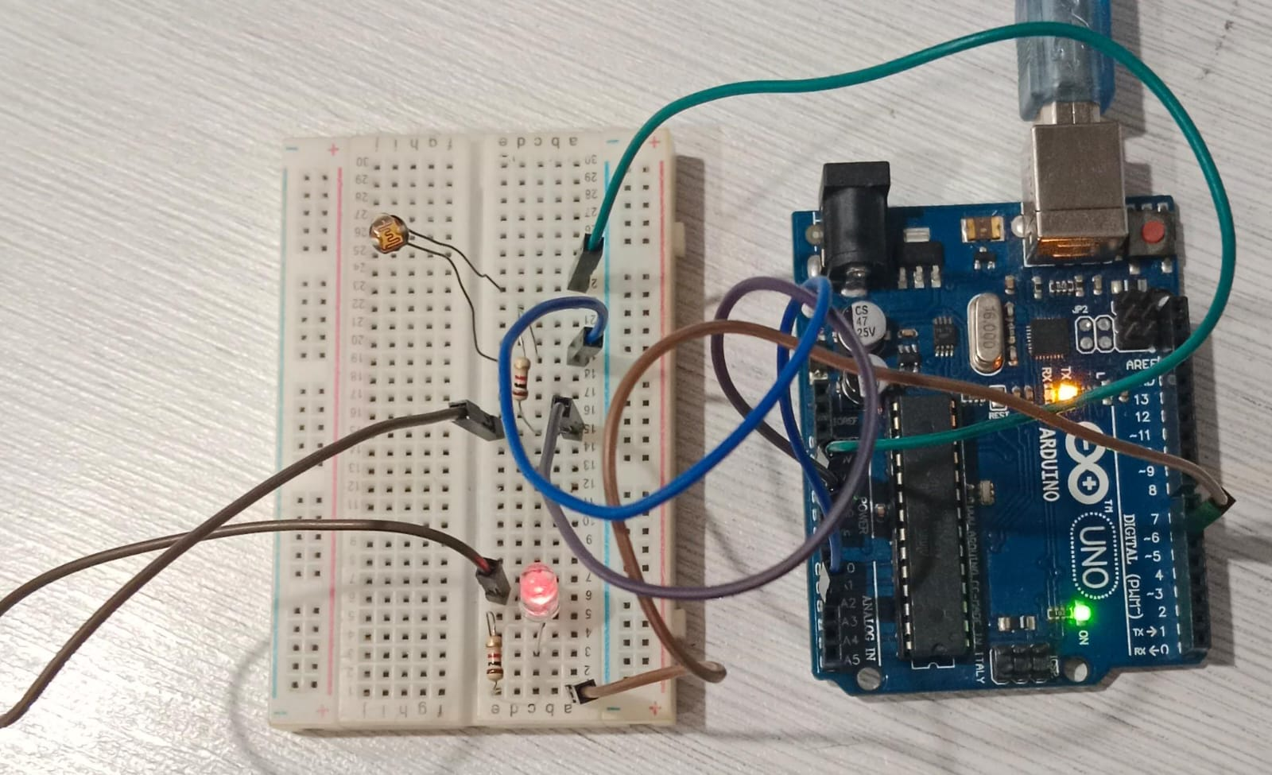

**POST LAB TASKS**

**Q1: Suggest a circuit that can made using LED and LDR combinations that can be implemented at your home. Could you give a brief summary of their work?**

**ANSWER:** I have ability to construct a circuit including LED and LDR, the circuit will activate or deactivate the LED through light radiation, more excess of light will bright more LED bright. We have done during this my lab task in university but this is different thing to give more light to LED. LED gives brightness until its capacity.

**Q2: Explain Pulse Width Modulation with the help of a graph.**

**ANSWER**: Pulse Width Modulation (PWM) is a method that converts analog data into a pulsing signal. It is often used in applications like as limiting the power supplied to electronic equipment, dimming lights, and controlling the speed of motors.

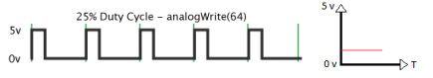

Showing in graph, oscillate between 0 to 5v and pulsing signal reach upto 5v.

**Comment to the report: ________________________________________________________________________**

**Signature of Lecturer: ______________________**